3.FACTORY DESIGN PATTERN

import java.io.\*;

abstract class EBBill

{

protected double rate;

abstract void getrate();

public void calculateBill(int units)

{

System.out.println(units\*rate);

}

}

class Domestic extends EBBill

{

public void getrate()

{

rate=3.50;

}

}

class Institutional extends EBBill

{

public void getrate()

{

rate=5.50;

}

}

class Commercial extends EBBill

{

public void getrate()

{

rate=7.50;

}

}

class GetPlanFactory

{

public EBBill getPlan(String plantype)

{

if(plantype==null)

{

return null;

}

if(plantype.equalsIgnoreCase("Domestic"))

{

return new Domestic();

}

else if(plantype.equalsIgnoreCase("Institutional"))

{

return new Institutional();

}

else if(plantype.equalsIgnoreCase("Commercial"))

{

return new Commercial();

}

return null;

}

}

class FactoryDesignPattern1

{

public static void main(String args[])throws IOException

{

GetPlanFactory p=new GetPlanFactory();

DataInputStream ds=new DataInputStream(System.in);

System.out.println("Enter the planname:");

String planname=ds.readLine();

System.out.println("Enter the units:");

int units=Integer.parseInt(ds.readLine());

EBBill pl=p.getPlan(planname);

System.out.println("Bill amount for"+planname+"is");

pl.getrate();

pl.calculateBill(units);

}

}

Output1:

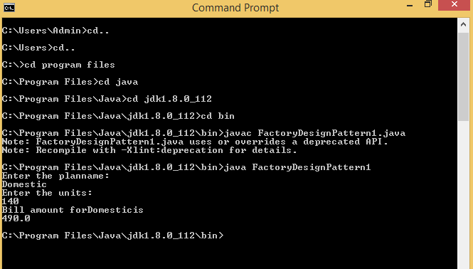

Output2:

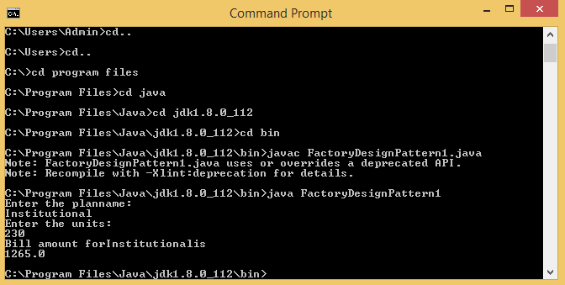

Output:3

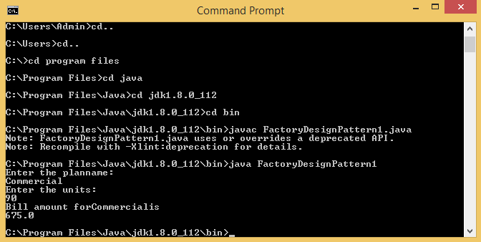

Output4:

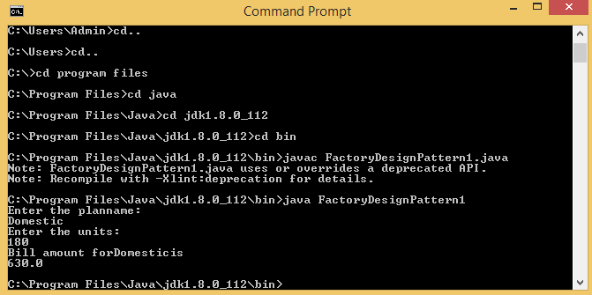

Output5:

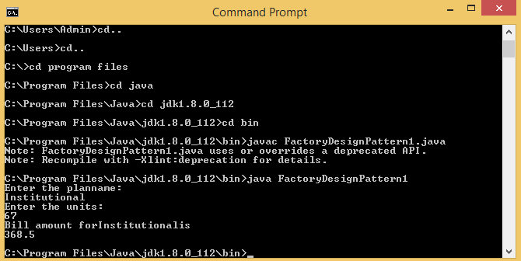

4.PROTOTYPE DESIGN PATTERN

import java.io.\*;

interface Prototype

{

public Prototype getClone();

}

class StudentRecord implements Prototype

{

String name,dept;

int id,m1,m2,m3,tot;

float avg;

StudentRecord()

{

System.out.println("\t Name \t ID \t Department \t M1 \t M2 \t M3 \t Total \t Average");

}

StudentRecord(String name,int id,String dept,int m1,int m2,int m3)

{

this();

this.name=name;

this.id=id;

this.dept=dept;

this.m1=m1;

this.m2=m2;

this.m3=m3;

}

void showRecord()

{

tot=m1+m2+m3;

avg=tot/3;

System.out.println("\t" +name+ "\t" +id+ "\t" +dept+ "\t" +m1+ "\t" +m2+ "\t" +m3+ "\t" +tot+"\t"+avg);

}

public Prototype getClone()

{

return new StudentRecord(name,id,dept,m1,m2,m3);

}

}

class PrototypeDesignPattern

{

public static void main(String args[])throws IOException

{

DataInputStream ds=new DataInputStream(System.in);

System.out.print("Enter the name:");

String name=ds.readLine();

System.out.print("Enter id:");

int id=Integer.parseInt(ds.readLine());

System.out.print("Enter department:");

String dept=ds.readLine();

System.out.print("Enter mark1:");

int m1=Integer.parseInt(ds.readLine());

System.out.print("Enter mark2:");

int m2=Integer.parseInt(ds.readLine());

System.out.print("Enter mark3:");

int m3=Integer.parseInt(ds.readLine());

StudentRecord s=new StudentRecord(name,id,dept,m1,m2,m3);

StudentRecord s1=(StudentRecord)s.getClone();

s.showRecord();

}

}

Output1:

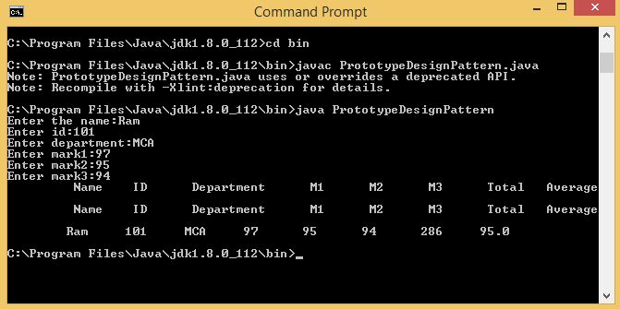

Output2: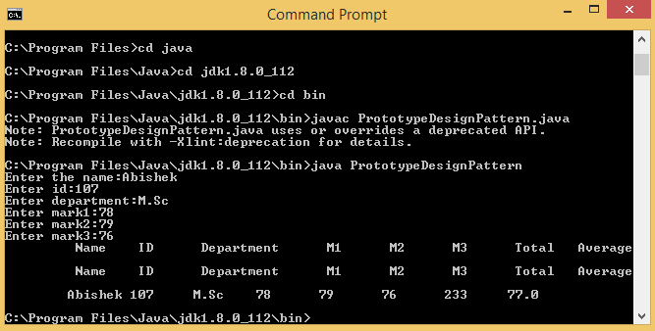

Output3:

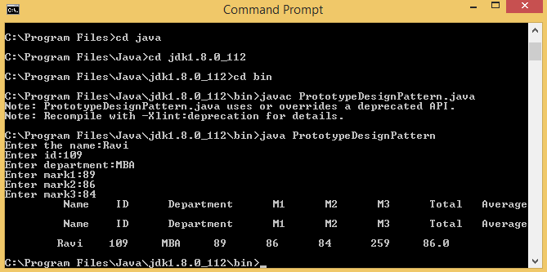

Output4:

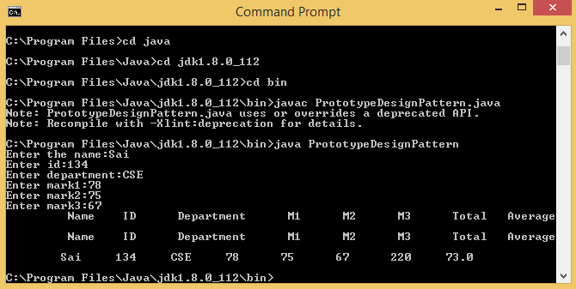

Output5:

